STEP 1: Safety Plan – Youth complete their answers below:
1. Warning signs- What I need to be aware of and watch out for to stay well? (such as: arguing with family/friends, increase substance use)
2. Coping strategies- What can I do to distract myself when I don’t feel well? (such as: exercise, watch TV, play game)
3. Self-care- What are some activities I can do to make me feel good? (such as: go for a walk, meet a friend)
4. Support- Who are the people that can help me stay well? (such as: school counsellor, friend, counsellor)
STEP 2: Know where to go for help
People I can call for help- Keep Safety Card Handy | Other Important Resources
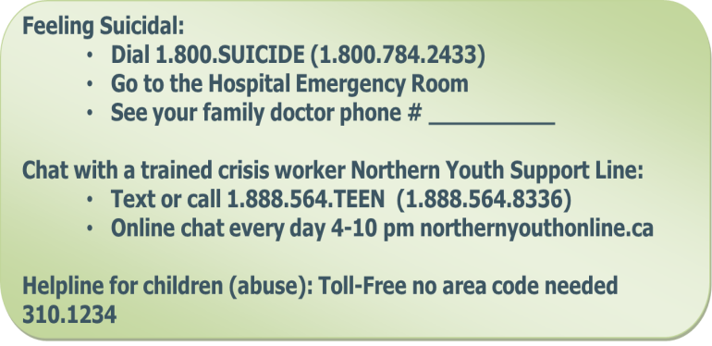 | 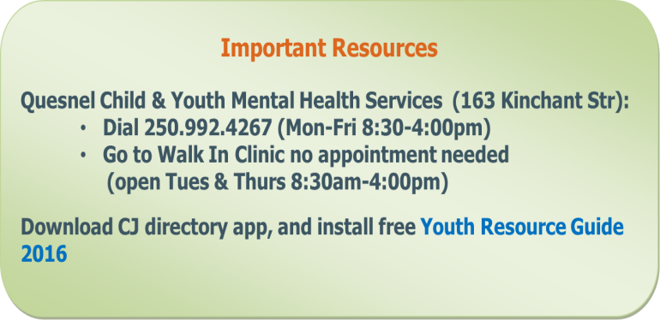
CYMH clinician: ______________________250.992.4267 | Mindshift (available in the App store) www.anxietybc.com/resources/mindshift-app
School Counsellor:____________________ | Kelty Mental Health Resource Centre  1-800-665-1822 www.keltymentalhealth.ca
Friendship Center Youth Support Worker: ___________________________ Phone:250 992 8347 | Rep4rights(available in the App store) www.rcybc.ca/rep4rights
Other_______________________________
STEP 3: Strategies for Parent/Guardian to ensure safety at home
❑Monitor child/youth for 48-hours
❑Identify crisis support contacts for youth (names:_________________,________________, ________________)
❑Make environment safe; put away sharp objects, pills and medications; no access to weapons
❑Once a day until Dr./CYMH follow-up occurs, ask your child/youth whether they have thoughts about suicide
❑Have an open discussion about appropriate internet use
❑Beware of isolating behaviour; changes in mood, sleep, eating patterns, normal activities; statements of hopelessness, and/or signs of drugs/alcohol use
❑Supervise child/youth when taking medications (if prescribed)
❑Other: _______________________________
❑I consent to my/my child’s medical records being sent to: CYMH:______ SU: ______ (initials)
Discharge Safety Plan and Discharge/Referral Communication plan forms faxed to: ❑GP/FP/NP ❑CYMH ❑SU
Youth Signature: ____________________________ Parent/Guardian Signature: ____________________________
Physician/Clinician Signature: ________________________Printed name: ____________________Date: _________

