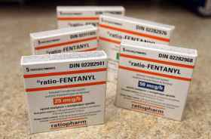  Prescription Fentanyl Patches  Symptoms of an overdose can include one or more of these warning signs:  - Very shallow breathing or not breathing at all  - Cold, clammy skin  - Lips and nails turning blue  - Choking or throwing up  - Pupils are tiny/pin point  - Gurgling sounds or snoring while breathing  - Person passes out and you cannot wake them up  - Seizures or convulsions  Fentanyl Facts  -Much more toxic then other opioids  -Overdose can happen with small amounts  -Falsely sold as other drugs (eg; oxycodone)  -Often mixed with other drugs and contaminates  -Contributed to an estimated 90 deaths in BC in 2014  Overdose can happen when you take too much of a drug, or a combination of drugs. An overdose looks different depending on which drugs you take. |  |  | CYMHSU Collaborative  A BC Initiative  Golden Fentanyl Education Seminar  Brought to you by the Golden Local Action Team as part of the Child and Youth Mental Health and Substance Use (CYMHSU) Collaborative, funded in partnership by Doctors of BC and the BC government.  For more information please go to  http://www.sharedcarebc.ca/ |  |  | Overdose Prevention  - What to do if you or a friend has/or is ODing on Fentanyl

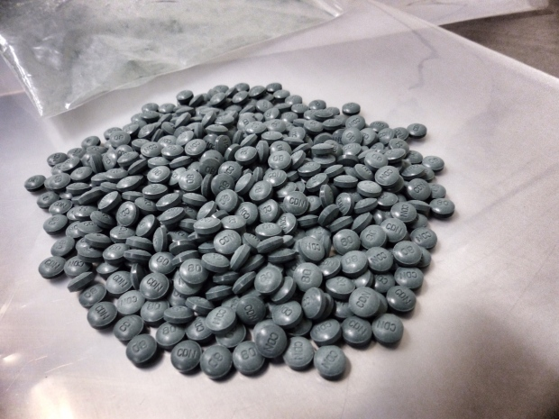  What NOT to do if someone with you is ODing  These are not good ideas and can make the problem worse!  DO NOT leave them alone. If you feel you need to leave, call 911, write a note for emergency services and tell them:  1) What the person took  2) How much they took  3) When they took it  DO NOT put the person in a cold bath or shower. Cooling their body will lower their heart rate even more then the drug will  DO NOT leave them on their back. Turn them so they’re lying on their side, that way they can’t choke on their vomit  DO NOT hit or hurt them to try and bring them around or wake them up  DO NOT give them any other drugs  DO NOT inject them with salt water  (And be sure to pick photos that show off what your company does best. Pictures should always dress to impress.) |  |  | Tips to Prevent an Overdose  - Don’t use alone! If there’s a problem, you can help each other out. Or have a DD to keep an eye out for you.  - Know your source and ask around. Make sure you know your dealer and how strong their product is  - Do “test shots” (smaller amounts than usual). You can always do more, you can’t do less.  - Start small if you haven’t used in a while. (like if you’ve been in jail or detox) Many people OD when starting back up again, because their tolerance is low.  - Know the risks of mixing drugs. You are more likely to OD if you use more than one downer at a time or mix with alcohol or other drugs.  - Speed-balls are a dumb idea (using opiates and cocaine together). You can have a delayed overdose when the cocaine wears off.  - Naloxone is a medication that can temporarily reverse the effects of an overdose from opioids (heroin, fentanyl, methadone) Have a kit with you and learn how to use it!!  Read… React… Remember It’s easy to lose your cool, so keep these tips handy and talk to your friends. |  |  | 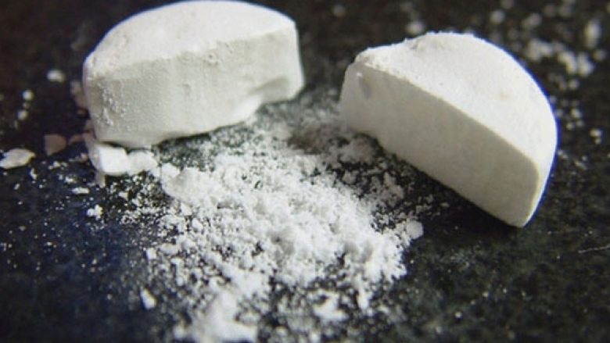  Pills can be crushed into powder and cut into other drugs  What to do if someone is ODing  1) Call 911  2) Use the Naloxone kit if you have one  3) Roll them into the recovery position if they are unconscious. This prevents problems like choking on their tongue or vomiting  4) Breathe for them if they stop breathing. Use CPR. Tilt their head back, make sure their airway is clear, give them a breath every 5 seconds  5) Stay with them until help comes. If you can’t stay, write a note and leave it with them for EMS.  When an OD happens, remembering these tips can save a life. If you’re going to use, educate yourself. Don’t be afraid to talk to your friends, family and others in your circle.

